Paper Title (16 Bold)

Author (14)

¹Department of Applied Sciences and Humanities, Dronacharya College of Engineering, Gurgaon-122506

²Department of Statistics, Amity Institute of Applied Sciences, Amity University, Noida-201313

³Department of Statistics, M. D. University, Rohtak-124001.(10)
Corresponding Author: xxxx .(10)

ABSTRACT: The main aim of the present paper is to determine economic analysis of a warm standby system of non-identical units by using Semi-Markov process and regenerative point technique. There are two units in the system–one (main) unit is initially operational and the second (duplicate) unit in warm standby. A single repair facility is provided to the system immediately to rectify the faults. The units work as new after repair. Each unit has operative and complete failure modes. The random variables associated with failure and repair times are statistically independent. Graphs are drawn to depict the behavior of some important economic measures such as MTSF, availability and profit for arbitrary values of the parameters.
KEYWORDS: Economic Analysis, Non-Identical units, Regenerative point technique and Warm standby.
---------------------------------------------------------------------------------------------------------------------------------------
Date of Submission: xx-xx-xxxx Date Of Acceptance: xx-xx-xxxx
---------------------------------------------------------------------------------------------------------------------------------------

- INTRODUCTION (10 Bold)
Several approaches for performance improvement of maintainable systems have been adopted by the scientists and engineers while designing the model of the system. The method of redundancy in diverse modes has also been used to increase efficiency and availability of these systems. A lot of research work has been carried out on stochastic modeling of cold standby redundant systems of identical units with different repair policies. [1] Analyzed cost-benefit of a one-server two-unit cold standby system with repair and preventive maintenance. [2] Explained reliability and availability of a system with standby and common cause failures. [3] Has discussed profit of a system with two- units having guarantee periods and delayed operation of standby. [4] Analyzed of a two-unit warm standby system subject to degradation. [5] Studied cost-benefit analysis of series systems with warm standby components and general repair time.
But, sometimes it is very difficult on the part of the users to keep a high cost identical unit in cold standby. And, in such a situation a duplicate unit may be kept as spare in order to its use in emergency and also to provide services to the customers for a considerable period. On the other hand, this unit can also be used to work in warm standby. [6] Evaluated probabilistic analysis of a single-server system operating under different weather conditions. Reliability and economic analysis of a system operating under different weather conditions have been discussed by [7]. [8] Evaluated reliability analysis of a system under preventive maintenance. [9] Obtained steady state analysis of an operating system with repair at different levels of damages subject to inspection and weather conditions. [10] Analyzed a repairable system operating under different weather conditions. Reliability measures of a cold standby system with preventive maintenance and repair have been considered by [11]. [12] Analyzed reliability of a single-unit system with inspection subject to different weather conditions. [13] Evaluated impact of abnormal weather conditions on various reliability measures of a repairable system with inspection. Economic analysis of a system reliability model with priority to preventive maintenance over repair subject to weather conditions have been studied by [14]. [15] Stochastic analyzed of a cold standby system with server failure. [16,17,18] Analyzed stochastically of a two-unit system with standby and server failure subject to inspection, conditional failure of the server, and priority to inspection over repair respectively.
Recently, [19, 20] evaluated profit of a two unit standby system operating under different weather conditions subject to inspection, free from any other discipline respectively. The purpose of the present study is to obtain reliability measures of a system of non-identical units with warm standby approach. There are two units in the system- one is the main unit is initially operational and the second (duplicate) unit in warm standby. Single repair facility is provided to the system immediately to rectify the faults. The units work as new after repair. Each unit has operative and complete failure modes. The random variables related to failure and repair times are statistically independent. The expressions for various reliability characteristics including mean sojourn times, mean time to system failures (MTSF), availability, busy period analysis, expected number of visit by server and profit function are derived using semi-Markov process and regenerative point technique. The results for particular cases have been obtained to depict the graphical behavior of some important reliability characteristic.
- NOTATIONS (10 Bold)

M₀ : Main unit is in working mode.

Dws/D₀ : Duplicate unit is in warm standby/operative mode.

Mfur/MFUR : Main unit is failed and under repair/under repair continuously from

previous state.

Mfwr : Main failed unit is waiting for repair.

Dfur/DFUR : Duplicate unit is failed and under repair/under repair continuously from

previous state.

Dfwr : Duplicate unit is failed and waiting for repair.

λ/λ₂ : Constant failure rate of duplicate unit in warm standby/operative mode.

λ₁ : Constant failure rate of the main unit.
g(t)/G(t) : p.d.f/c.d.f. of repair time of the main unit.
g₁(t)/G₁(t) : p.d.f/c.d.f. of repair time of the duplicate unit.
q_{ij}(t)/Q_{ij}(t) : p.d.f./c.d.f. of first passage time from i^{th} to j^{th} regenerative state or to j^{th}
failed state without staying in any other regenerative state in (0,t].
m_{ij} : The unconditional mean time taken by the system to transit from any
regenerative state S_{i} when it (time) is counted from epoch of entrance in to the state S_{j.} Mathematically, it can be written as
: Mean sojourn time in state Si which is given by
, where T denotes the time to system
failure.
M_{i}(t) : Probability that the system is initially up in the regenerative state S_{i} is up
at time t without passing through any other regenerative state.
W_{i}(t) : Probability that the system is busy in the state S_{i} up to time t, without
making any transition to any other regenerative state or before returning to the same via one or more non-regenerative states.
Ⓢ\© : Symbol of Laplace Stieltjes Convolution/ Laplace Convolution.
: Laplace Stieltjes transform/Laplace transform/ alternative function.

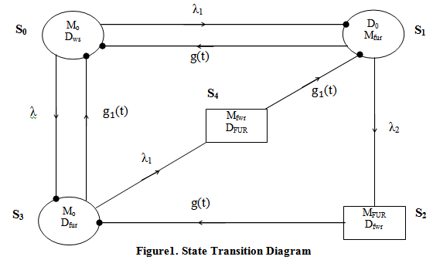

- TRANSITION PROBABILITIES AND MEAN SOJOURN TIMES (10 Bold)
$p_{01 }=\frac{λ_{1}}{λ+λ_{1}}$ $p_{03}=\frac{λ}{λ+λ_{1}}$ $p_{10}=g^{*}\left(λ_{2}\right)$ $p_{12}=1-g^{*}\left(λ_{2}\right)$
$p_{30}={g_{1}}^{*}(λ_{1})$ $p_{34}=1-{g_{1}}^{*}(λ_{1})$ $p_{41}=p_{23}=1$ (1)
It can be easily verified that
$$p_{01}+p_{03}=p_{10}+p_{12}=p_{23}=p_{30}+p_{34}=p_{41}=1$$
The mean sojourn times in the state S_{i} is given by
$μ_{i}=\int_{0}^{∞}{P\left(T_{i}>t\right)dt }= \sum_{j}{m_{ij}}$ (2)
The unconditional mean time taken by the system to transit for any regenerative state S_{i} when it (time) is counted from the epoch of entrance into the state S_{j} is mathematically, states as
$m_{ij}=\int_{0}^{∞}{td\left[Q_{ij}(t)\right]}dt=-q_{ij}^{*^{,}} (0)$ (3)
$μ_{0}=m_{01}+m_{03}$ $μ_{1}=m_{10}+m_{12}$ $μ_{2}=m_{23}$ $μ_{3}=m_{34}+m_{30}$
$μ_{4}=m_{41}$ $μ_{1}^{'}=m_{13.2}+m_{10}$ $μ_{3}^{'}=m_{31.4}+m_{30}$ (4)

- RELIABILITY AND MEAN TIME TO SYSTEM FAILURE (MTSF) (10 Bold)
Let φ_{i}(t) be the c.d.f of first passage time from the regenerative state S_{i} to a failed state. Regarding the failed state as absorbing state, we have the following recursive relations for φ_{i} (t):
$ϕ_{0}\left(t\right)=Q_{01}\left(t\right)Ⓢϕ_{1}\left(t\right)+Q_{03}\left(t\right)Ⓢϕ_{3}\left(t\right)$
$ϕ_{1}\left(t\right)=Q_{10}\left(t\right)Ⓢϕ_{0}\left(t\right)+Q_{12}\left(t\right)$
$ϕ_{3}\left(t\right)=Q_{30}\left(t\right)Ⓢϕ_{0}\left(t\right)+Q_{34}\left(t\right)$ (5)
Taking L.S.T. of above relation (5) and solving for${ ϕ}_{0}^{**}(s)$ we have
(6)

The reliability of the system model can be obtained by taking inverse L.T. of (6) equation

(7)

- STEADY STATE AVAILABILITY (10 Bold)
Let A_{i}(t) be the probability that the system is in upstate at instant 't' given that the system entered regenerative state S_{i} at t = 0. The recursive relations for A_{i} (t) are given as:
$A_{0}\left(t\right)=M_{0}\left(t\right)+q_{01}\left(t\right)©A_{1}\left(t\right)+q_{03}\left(t\right)©A_{3}\left(t\right)$
$A_{1}\left(t\right)=M_{1}\left(t\right)+q_{10}\left(t\right)©A_{0}\left(t\right)+q_{13∙2}\left(t\right)©A_{3}\left(t\right)$
$A_{3}\left(t\right)=M_{3}\left(t\right)+q_{30}\left(t\right)©A_{0}\left(t\right)+q_{31∙4}\left(t\right)©A_{1}\left(t\right)$ (8)
where
$M_{0}\left(t\right)=e^{-\left(λ+λ_{1}\right)t}$, $M_{1}\left(t\right)=e^{-λ_{2}t}\overline{G\left(t\right)}$, $M_{3}\left(t\right)=e^{-λ_{1}t}\overline{G_{1}\left(t\right)}$ (9)
Taking L.T. of relation (8 and 9) and solving for $A_{0}^{*} (s)$, the steady state availability is given by
$A_{0}\left(∞\right)=\lim_{s→0}{s A_{0}^{*}}\left(s\right)=\frac{N_{A}}{D}$ (10)
where
$$N_{A}=µ_{0 }\left[1-p_{13∙2}p_{31.4}\right]+µ_{1 }\left[p_{01}+p_{03}p_{31.4}\right]+µ_{3 }[ p_{03}+p_{01}p_{13.2}]$$
$D=µ_{0 }\left[1-p_{13.2}p_{31.4}\right]+μ_{1}^{'}\left[p_{01}+p_{03}p_{31.4}\right]+μ_{3}^{'}[ p_{03}+p_{01}p_{13.2}]$ (11)

- BUSY PERIOD OF THE SERVER (10 Bold)
Let $B_{i}\left(t\right)$ be the probability that the server is busy in repairing the unit due to failure at an instant‘t’ given that the system entered state S_{i} at t = 0 .The recursive relations for $B_{i}\left(t\right)$ are given below:
$B_{0}\left(t\right)=q_{01}\left(t\right)©B_{1}\left(t\right)+q_{03}\left(t\right)©B_{3}\left(t\right)$
$B_{1}\left(t\right)=W_{1}\left(t\right)+q_{10}\left(t\right)©B_{0}\left(t\right)+q_{13∙2}\left(t\right)©B_{3}\left(t\right)$
$B_{3}\left(t\right)=W_{3}\left(t\right)+q_{30}\left(t\right)©B_{0}\left(t\right)+q_{31∙4}\left(t\right)©B_{1}\left(t\right)$ (12)
where $W_{1}= e^{-λ_{2} t}\overline{G(t)}+(λ_{2}e^{-λ_{2}t}\overline{G(t)}©1)\overline{G(t)}$
$W_{3}= e^{-λ_{1}t}\overline{G_{1}(t)} +(λ_{1}e^{-λ_{1}t}\overline{G_{1}\left(t\right)}©1)\overline{G_{1}(t)}$ (13)
Taking L.T. of relations (12 and 13) solving for $B_{0}^{*}\left(s\right)$ the time for which server is busy due to repair is given by
$B_{0}=\lim_{S→0}{SB_{0}^{*}\left(S\right) =\frac{N_{B}}{D}}$ and D is already mentioned in (11).
where $N_{B}= μ_{1}^{'}\left[p_{01}+p_{03}p_{31.4}\right]+ μ_{3}^{'}[ p_{03}+p_{01}p_{13.2}]$ (14)

- EXPECTED NUMBER OF VISITS BY THE SERVER (10 Bold)
Let $N_{i}\left(t\right)$be the expected no of visits by the server for repair in (0, t] given that the system entered the regenerative state S_{i} at t=0. The recursive relations for${ N}_{i}\left(t\right)$ are given as:

$N_{0}\left(t\right)=Q_{01}\left(t\right)(s)\left[1+N_{1}\left(t\right)\right]+Q_{03}\left(t\right)(s)\left[1+N_{3}\left(t\right)\right]$

$N_{1}\left(t\right)=Q_{10}\left(t\right)(s)N_{0}\left(t\right)+Q_{13∙2}\left(t\right)(s)N_{3}\left(t\right)$

$N_{2}\left(t\right)=Q_{30}\left(t\right)(s)N_{0}\left(t\right)+Q_{31∙4}\left(t\right)(s)N_{1}\left(t\right)$ (15)
Taking LST of relations (1.12-1.14) and solving for${ N}_{0}^{**}(s)$. The expected no of visits of the server can be obtained as:
$N_{0}\left(∞\right)=\lim_{s→0}{ sN_{0}^{**}(s)}$ (16)
$N_{0}=\frac{N_{v}}{D}$
where $N_{v}=1+p_{31.4}+p_{13.2}$ and D is already define in (11)

- COST- BENEFIT ANALYSIS (10 Bold)
Profit incurred to the system model in steady state is given by
$P=T_{1}A_{0}-T_{2}B_{0}-T_{3}N_{0}$ (17)
T₁ = Revenue per unit up time of the system, T₂ = Cost per unit time for which server is busy
T₃ = Cost per unit to the visit by the server

- PARTICULAR CASE (10 Bold)
Suppose g(t) = ${θe}^{-θt}$ , g₁(t) =${re}^{-rt}$ for particular case: (18)
The transition probabilities p₁₀, p_{12,} p₃₀, p₃₄are given below
$p_{10 }=\frac{θ}{θ+λ_{2}}$ , $p_{12 }=\frac{λ_{2}}{θ+λ_{2}}$ , $p_{30 }=\frac{r}{r+λ_{1}}$ , $p_{34 }=\frac{λ_{1}}{r+λ_{1}}$
The mean sojourn times µ_{i} in the state S_{i}, are given below
$µ_{1 }=\frac{1}{θ+λ_{2}}$ , $µ_{2 }=\frac{1}{θ}$ , $µ_{3 }=\frac{1}{r+λ_{1}}$ , $µ_{4 }=\frac{1}{r}$ , $µ_{1 }^{'}= \frac{1}{θ}$ ,$µ_{3 }'=\frac{1}{r}$
Also, $M_{0 }=\frac{1}{λ+λ_{1}}$, ${ M}_{1 }={ µ}_{1 }=\frac{1}{θ+λ_{2}}$ ,$µ_{3 }=M_{3 }=\frac{1}{r+λ_{1}}$,${ W}_{1 }=\frac{1}{θ}$ and ${ W}_{3 }=\frac{1}{r}$ (19)

- CONCLUSION (10 Bold)
The behavior of mean time to system failure, availability and profit has been observed for arbitrary values of the parameters as shown in the figure 2, 3 & 4. It is observed that these reliability measures keep on decreasing with the increase of failure rate λ and λ₂. While the reliability measures increases with the increase of repair rate r and θ. Hence the performance of a system of non-identical units can be improved by increasing the repair rate and decreasing the failure rate of duplicate unit.

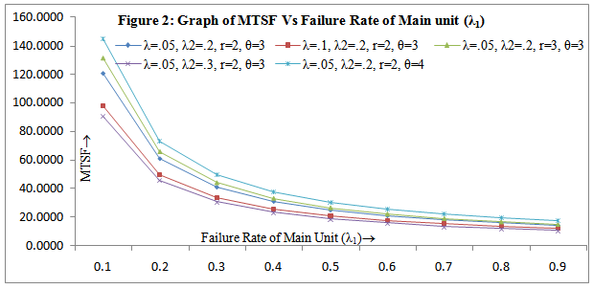

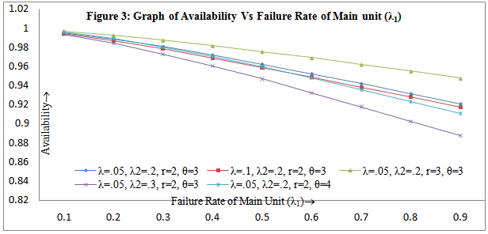
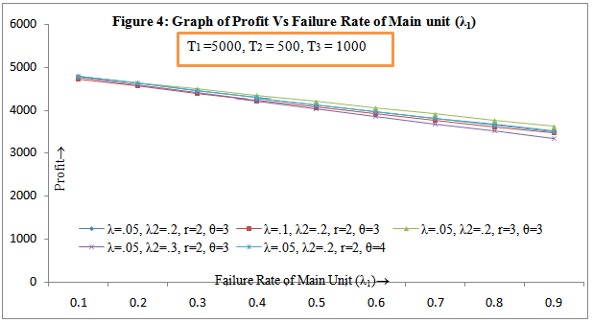

REFERENCES (10 Bold)
- M.N. Gopalan and H. E. Nagarwalla, Cost-benefit analysis of a one-server two-unit cold standby system with repair and preventive maintenance, Microelectronics Reliability, 25(2), 1985, 267 – 269.
- B.S. Dhillon, Reliability and availability analysis of a system with standby and common cause failures, Microelectronics Reliability, 33(9), 1992, 1343-1349.
- R. Gupta and A. Chaudhary, Profit analysis of a system with two- units having guarantee periods and delayed operation of standby, Microelectronic Reliability, 34, 1994, 1387-1390.
- G.S. Mokaddis, S.W. Labib and A.M. Ahmed, Analysis of a two-unit warm standby system subject to degradation, Microelectronics Reliability, 37, 1997, 641-648.
- Kuo-Hsiung Wang, Yi-Chun Liu and Wen Lea Pearn, Cost- benefit analysis of series systems with warm standby components and general repair time, Mathematical Methods of Operations Research,61(2), 2005, 329–343.
- S.C. Malik and M.S. Barak, Probabilistic analysis of a single-server system operating under different weather conditions, Journal of Mathematical Analysis and Approximation Theory, 2(2), 2007, pt-II, 165-172.
- S.C. Malik and M.S. Barak, Reliability and economic analysis of a system operating under different weather conditions, Proc. of Journal of National Academy of Sciences (India), 79, 2009, 205-213.
- S.C. Malik, P. Nandal and M.S. Barak, Reliability analysis of a system under preventive maintenance, Journal of Mathematics and Systems Sciences, 5(1), 2009, 92-115.
- D. Pawar, S.C. Malik, and S. Bahl, Steady state analysis of an operating system with repair at different levels of damages subject to inspection and weather conditions. International Journal of Agriculture and Statistical Sciences, 6(1), 2010, 225-234.
- A.K. Barak and M.S. Barak, Analysis of a repairable system operating under different weather conditions, International Journal of Computer Applications, 84(9), 2013,12-16.
- S.C. Malik and Sudesh, K. Barak, Reliability measures of a cold standby system with preventive maintenance and repair, International Journal of Reliability, Quality and Safety Engineering, 20(6), 2013, DOI: 10.1142/S0218539313500228.
- A.K. Barak, S.C. Malik and M.S. Barak, Reliability analysis of a single-unit system with inspection subject to different weather conditions, Journal of Statistics and Management Systems, 17(2), 2014, 195-206.
- A.K. Barak and M.S. Barak, Impact of abnormal weather conditions on various reliability measures of a repairable system with inspection, Thailand Statistician, 14(1), 2016, 35-45.
- M.S. Barak and Neeraj, Economic analysis of a system reliability model with priority to preventive maintenance over repair subject to weather conditions, International Journal of Emerging Technology and Advanced Engineering,6(7), 2016, 293-301.
- M.S.Barak and Dhiraj Yadav, Stochastic analysis of a cold standby system with server failure, International Journal of Mathematics and Statistics Invention, 4(6), 2016, 18-22.
- M.S. Barak, Dhiraj Yadav and Sudesh, K. Barak, Stochastic analysis of a cold standby system with conditional failure of server, International Journal of Statistics and Reliability Engineering, 4(1), 2017, 65-69.
- M.S. Barak, Dhiraj Yadav and Sudesh, K. Barak, Stochastic analysis of a two-unit system with standby and server failure subject to inspection, Life Cycle Reliability and Safety Engineering, 2017, DOI: https://doi.org/10.1007/s41872-017-0033-5
- M.S. Barak, Dhiraj Yadav and Sudesh, K. Barak, Stochastic analysis of two-unit redundant system with priority to inspection over repair, Life Cycle Reliability and Safety Engineering, 2017, DIO: https://doi.org/10.1007/s41872-018-0041-0.
- M.S. Barak, Neeraj and Sudesh, K. Barak, Profit analysis of a two unit cold standby system operating under different weather conditions subject to inspection, Application of Applied Mathematics: An International Journal (AMM),13(1), 2018, 67-83.
- M.S. Barak, Neeraj and Sudesh, K. Barak, Profit analysis of a two-unit cold standby system model operating under different weather conditions, Life Cycle Reliability and Safety Engineering, 2018, DOI: https://doi.org/10.1007/s41872-018-0048-6.

